***Institute of Space Technology***

***DevCon’23***

**Theme: Gender Equality**

***Team:***

***Furqan Ali – 200901073***

***Muhammad Jamil Khalid – 200901082***

***Abeer Ilyas – 200901055***

***Vanya Ahmed Siddiqui – 200901095***

***Eisha Baig – 200901015***

# **Abstract**

This report provides an overview of the EqualPay project, developed by the TechBridge team to address the gender pay gap in Pakistan. The report includes a problem statement that highlights the persistent issue of gender pay gap in Pakistan and the need to address it. The legal frameworks related to gender pay gap in Pakistan are also discussed. The report details the Software Development Life Cycle (SDLC) approach used, which is Agile methodology, and describes the prototype of the app developed using Figma. The report also includes the proposed solution, future enhancements, and the potential impact of the solution on individuals and society as a whole. The project aims to empower individuals, especially women, to negotiate for equal pay and advocate for their rights in the workplace and create a more equitable future.

Table of Contents

**Abstract** 1

**Introduction** 3

**Problem Statement** 3

**Legal Frameworks related to Gender Pay Gaps in Pakistan** 4

**Software Development Life Cycle(SDLC) Model** 5

• **Planning** 5

• **Design** 5

• **Development** 5

• **Testing** 5

• **Documentation** 5

**Figma-based prototype** 6

**Solution** 9

• **Registration and Login** 9

• **Password Reset** 9

• **User Profile** 9

• **Salary Comparison** 9

• **Negotiation Tips** 9

• **Conclusion** 9

**Future Enhancements** 9

• **Company-Based Salary Comparison** 10

• **Data Visualization** 10

• **Personalized Action Plans** 10

• **Community Feedback** 10

• **Gamification** 10

**Conclusion** 10

# **Introduction**

Gender pay gap refers to the difference in earnings between men and women in the workforce, and it has been a persistent problem in many countries worldwide, including Pakistan. Despite the advances made in recent years to promote gender equality in the workplace, women continue to earn less than men for the same job, qualifications, and experience. The gender pay gap not only affects women's financial security, but it also perpetuates social and economic inequalities, making it a pressing issue that needs to be addressed.

In this report, we will present the EqualPay project, developed by the TechBridge team, to provide a solution to the gender pay gap in Pakistan. Our project aims to develop a mobile application called EqualPay, which will help people negotiate for fair pay and raise awareness about the issue. We will provide an overview of our project, including the problem statement, legal frameworks related to gender pay, our SLDC approach using Agile methodology, the Figma-based prototype of the app, and our proposed solution. We will also discuss future enhancements and the potential impact of our solution on individuals and society as a whole.

# **Problem Statement**

The gender pay gap remains a persistent issue in many countries, including Pakistan. To address this problem, we have designed and developed an initial version of an app that aims to help individuals determine whether they are being underpaid due to their gender and provide guidance on how to negotiate for a raise. To inform the development of this app, we conducted a survey of the working class and graduate students in Pakistan to collect data on their views on the gender pay gap and their preferences for an app that addresses this issue.

Our survey found that a significant proportion of women in the workforce in Pakistan feel they are being underpaid due to their gender. Of the total sample size, 33.3% were female and 66.7% were male. When asked about their views on gender pay gap, 55.6% of the sample size believed that it exists in Pakistan, 11.1% denied its existence, and the rest were unsure. Respondents also indicated that gender pay gap is more prevalent in private businesses, trade, retail, public administration, finance insurance, agriculture, manufacturing, IT, and technology industries.

Interestingly, 77.8% of the sample size stated that they would use an app to determine whether they are being underpaid or not and seek guidance from it to negotiate for an increase in their salary. The rest said they would not use such an app. Respondents recommended several features that they would like to see in an app aimed at addressing gender pay gap, including company-based salary versus the number of years of experience, a salary comparison tool, personalized salary analysis, negotiation advice, resources for further learning, anonymous community feedback, and personalized action plans.

Our app aims to incorporate these features and provide a valuable resource for people who want to be paid fairly. However, there is a need to further develop and refine the app based on user feedback and usability testing. Our goal is to make the app accessible and user-friendly for individuals in the workforce in Pakistan, especially women who may face gender-based pay discrimination. By providing guidance on how to negotiate for a raise and resources on the gender pay gap, our app has the potential to improve economic opportunities and promote gender equality in the workforce in Pakistan.

# **Legal Frameworks related to Gender Pay Gaps in Pakistan**

The Constitution of Pakistan guarantees equal rights and opportunities for all citizens without any discrimination on the basis of gender. However, despite these constitutional provisions, women in Pakistan continue to face gender-based pay discrimination in the workplace.

The Equal Remuneration Convention of the International Labor Organization (ILO) provides the legal framework for gender pay equality. Pakistan is a signatory to this convention and has an obligation to implement its provisions. The convention requires that men and women receive equal pay for work of equal value, which means that pay rates should be based on the nature of the work and not on the gender of the employee.

In Pakistan, the Industrial and Commercial Employment (Standing Orders) Ordinance, 1968, provides legal protection against gender-based pay discrimination. The ordinance requires that employers provide equal pay for equal work, which means that employees of the same establishment performing the same or similar work should receive equal pay regardless of their gender.

The Provincial Women Employment Act, 2017, is another legal framework aimed at promoting gender equality in the workplace. The act requires that employers provide equal opportunities and treatment to women in the workplace, including equal pay for equal work. The act also prohibits discrimination against women on the basis of gender in recruitment, selection, training, promotion, and other employment-related matters.

However, despite these legal frameworks, gender pay gap continues to persist in Pakistan. One of the major reasons for this is the lack of implementation and enforcement of these laws. There is also a need for greater awareness and education on gender-based pay discrimination among employers and employees. Our app aims to address this issue by providing resources and guidance on negotiating for equal pay and raising awareness about the issue of gender pay gap in Pakistan.

# **Software Development Life Cycle(SDLC) Model**

The EqualPay project was developed using the Agile methodology, which is a flexible and iterative approach to software development. The project had a duration of 3 weeks and involved the development of an android app using Kotlin in Android Studio for the frontend and SQLite for the database. Figma was used for designing the app.

The project went through several stages of the Software Development Life Cycle (SDLC) including:

## **Planning**

The planning phase involved defining the scope of the project, gathering requirements, and identifying the target audience. The TechBridge team conducted a survey to collect data on the views of the working class and graduate students in Pakistan regarding the gender pay gap and their preferences for an app that addresses this issue. The survey results were used to plan the features and design of the app.

## **Design**

In the design phase, the TechBridge team used Figma to create a prototype of the app. Meetings were held to discuss the design and gather feedback. Changes were made to the design based on the feedback received.

## **Development**

The development phase involved the creation of the frontend and backend of the app. Kotlin was used in Android Studio to develop the frontend of the app. SQLite was used for the database. The TechBridge team followed an Agile approach to development, with a focus on regular retrospectives to review progress and adjust.

## **Testing**

After the development phase was complete, the app was tested to ensure that it was working as intended. The TechBridge team used various testing techniques, including unit testing, integration testing, and user acceptance testing to ensure that the app met the requirements.

## **Documentation**

Finally, the TechBridge team created documentation for the app.

Overall, the EqualPay project followed the Agile methodology and went through the key stages of the SDLC. The result of this process was a basic functional android app that aims to address the issue of gender pay gap in Pakistan.

# **Figma-based prototype**

For our EqualPay project, we created a Figma-based prototype to visually represent the design and functionality of our mobile app. The prototype included the following screens:

**Welcome and loading screen:**

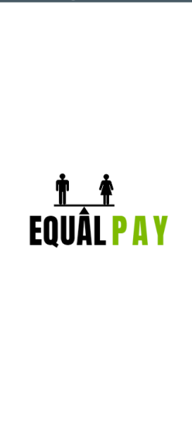

**Registration screens:**

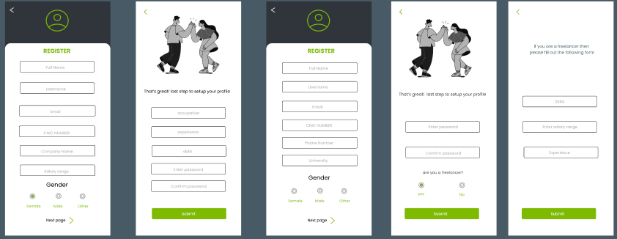

**Profile page:**

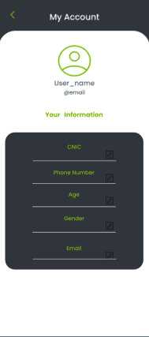

**Home page:**

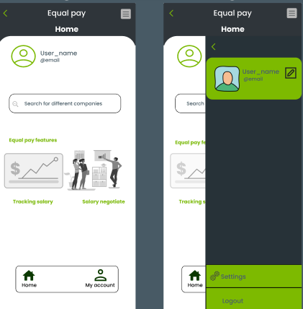

**Forget Password pages:**

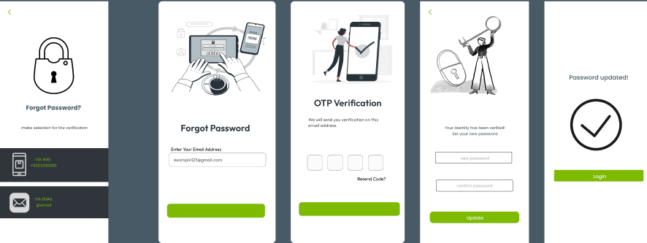

**Salary Comparison:**

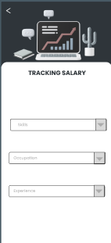

**Negotiating salary:**

The Figma-based prototype allowed us to visualize the user interface and user experience of our app and make necessary changes before moving into the development phase. We were able to incorporate user feedback and create a design that was user-friendly and accessible for our target audience.

# **Solution**

## **Registration and Login**

To use the app, the user must first register by providing their information such as name, email address, education, university, and work experience. They are also asked about their current salary to determine if they are being paid fairly. The registration process also includes the option to register as a student or an employee. Once registered, users can log in using their email and password.

## **Password Reset**

If the user forgets their password, they can use the "forgot password" feature. The app will send an OTP (One-Time Password) to the email address associated with the user's account. Once the user enters the OTP, they can reset their password.

## **User Profile**

The app allows users to view and edit their profile information at any time. This includes their personal details, work experience, and current salary. Users can also upload their resume to their profile for potential employers to view.

## **Salary Comparison**

Users can compare their salaries with others. This feature helps users determine if they are being paid fairly or not. The app uses a database of salary information to provide accurate comparisons.

## **Negotiation Tips**

The app provides users with negotiating tips. The app also provides users with action plans to help them negotiate for a raise.

## **Conclusion**

The EqualPay app provides a comprehensive solution to the gender pay gap in Pakistan by helping users determine if they are being paid fairly and providing them with the tools and resources to negotiate for equal pay. The app's features include registration and login, password reset, user profile, seeing others' profile, salary comparison, and negotiation tips. The app's user-friendly interface and accurate salary comparisons make it a valuable resource for individuals in the workforce in Pakistan.

# **Future Enhancements**

As we continue to refine and improve the EqualPay app, there are several future enhancements that we plan to implement. These enhancements will provide additional value to users and help us achieve our goal of promoting gender equality in the workforce in Pakistan. Here are some of the key enhancements we are considering:

* **Company-Based Salary Comparison**

Users have requested the ability to compare salaries at specific companies, as this would help them make informed decisions about potential employers. We plan to incorporate this feature, allowing users to compare salaries for specific companies based on their years of experience.

* **Data Visualization**

We plan to incorporate data visualization features that will allow users to easily see trends in salary data and understand the impact of the gender pay gap on their industry and the broader workforce.

## **Personalized Action Plans**

Based on user feedback, we plan to create personalized action plans for users who have identified that they are being underpaid due to their gender. These action plans will provide guidance on how to negotiate for fair pay and advocate for their rights in the workplace.

## **Community Feedback**

We plan to incorporate anonymous community feedback features, allowing users to share their experiences and insights about the gender pay gap in their industry. This will help create a supportive community for users who are facing discrimination and provide valuable insights into the systemic issues that contribute to the gender pay gap.

## **Gamification**

We plan to incorporate gamification features that will incentivize users to use the app regularly and engage with the content. These features could include points, badges, and leaderboards to encourage healthy competition and encourage users to continue learning about the gender pay gap and negotiating for fair pay.

By incorporating these future enhancements, we hope to make EqualPay a more valuable resource for individuals in the workforce in Pakistan, especially women who may face gender-based pay discrimination. We are committed to creating a more equitable future and look forward to continuing to improve the app to help achieve this goal.

# **Conclusion**

In conclusion, the development of this app was a challenging yet rewarding experience. We were able to utilize our freshly acquiredq51 knowledge of Android and database technologies to develop a solution for a social issue in Pakistan. Our use of an Agile approach allowed us to efficiently plan, design, and develop the app in a short amount of time.

We also believe that there is always room for improvement and future enhancements. We plan to include more features such as a messaging system for networking and collaboration, as well as expanding the app to other countries to help solve the issue of income inequality on a global scale.

We are grateful to ID-WARE and the collaborators for organizing DevCon'23, which brought us together as a team to work towards a common goal. It was a valuable learning experience that has helped us grow both personally and professionally. We look forward to future opportunities to work together and make a positive impact in the world.